# WWLLN – World Wide Lightning Location Network

The University of Washington operates a network of lightning location sensors at VLF (3-30kHz) that accurately monitors location and time for lightning strokes over the entire world. The World Wide Lightening Location Network - (WWLLN) project has been providing continuous accurate locations and times for lightning strokes globally since August 2003 [Lay et al., 2004; Rodger et al., 2005a; Jacobson et al., 2006].

*Figure 1* shows the real-time global lightning detection capabilities of the WWLLN. A real-time, global lightning detection system has a variety of applications in the scientific, commercial, and governmental sectors. Scientifically, it could provide better global tracking of severe storms, especially storms and hurricanes over the oceans. Its seasonal and yearly averaged data could be used as an indicator of global climate change [Schlegel et al., 2001].

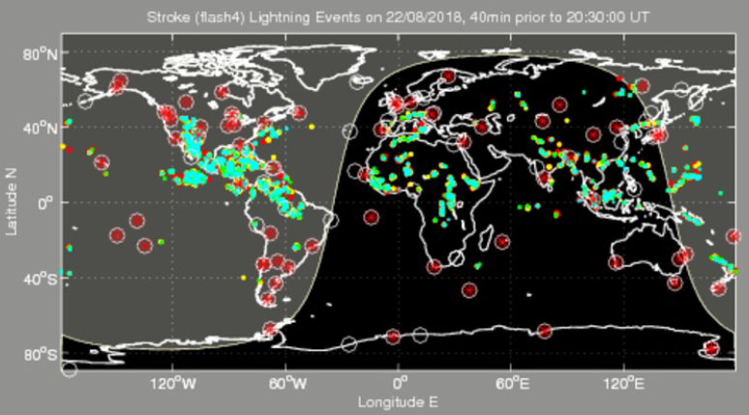

Figure . WWLLN world map for 22-08-2018 [https://wwlln.net].

This is achieved by the monitoring of spherics on the VLF system. Spherics are impulsive signals produced by lightning discharges. By calculating the Time of Group Arrival (ToGA) of the spherics, the location of lightning strikes is calculated. The TOGA is determined relative to GPS at each site from the progression of phase versus frequency using the whole wave train. Unlike current VLF methods which require transmission of the whole wave train from each site to a central processing site, the TOGA method requires transmission of a single number (the TOGA) for lightning location calculation. The WWLLN node at SANAE forms part of this network and actively contributes to the global database.

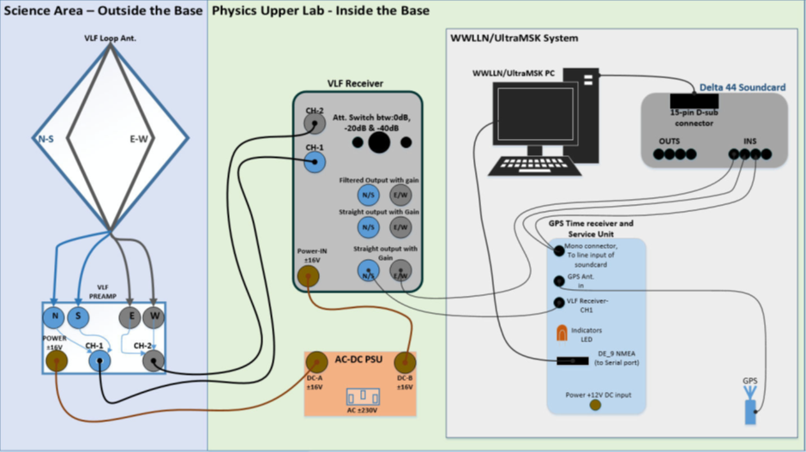

Figure . Diagram of the WWLLN/UltraMSK systems.

The spherics are picked up by the VLF antennae. The signal is amplified by the pre-amp. The amplified signal is then routed via a long (350 m) coaxial cable into the Base, to the Service Unit, which serves to isolate the signal via an audio transform. A schematic diagram of a WWLLN station is shown in *Figure 2*. The service unit feeds the signal to the UltraMSK/WWLLN PC via a Delta 44 sound card that digitises the signal.

The GPS provides one pulse per second input to the computer sound and to adjust the timestamp on each VLF waveform. The GPS also provides a NMEA() signal giving the exact location of SANAE. The requirements for the station computer are minimal: it must be able to run Linux and must have a sound card and serial port. Enough RAM is 248 MB, or 512 MB and 20-40 GB is plenty of hard-disk space. The computer also must be continuously connected to the internet. The global data are then posted to the internet every 10 minutes.